ISO/TC 193/SC 1

ISO/DIS 2611-1:2023(E)

ISO TC 193/SC 1/WG 25

Secretariat: NEN

Analysis of natural gas — Biomethane — Determination of halogenated compounds — Part 1: HCl and HF content by ion chromatography

© ISO 2023

All rights reserved. Unless otherwise specified, or required in the context of its implementation, no part of this publication may be reproduced or utilized otherwise in any form or by any means, electronic or mechanical, including photocopying, or posting on the internet or an intranet, without prior written permission. Permission can be requested from either ISO at the address below or ISO’s member body in the country of the requester.

ISO copyright office

CP 401 • Ch. de Blandonnet 8

CH-1214 Vernier, Geneva

Phone: +41 22 749 01 11

Fax: +41 22 749 09 47

Email: copyright@iso.org

Website: [www.iso.org](http://www.iso.org)

Published in Switzerland

Contents

Foreword v

Introduction vi

1 Scope 1

2 Normative references 1

3 Terms and definitions 1

4 Symbols and abbreviations 2

4.1 Symbols 2

4.2 Abbreviations 3

5 Principle 3

6 Reagents and consumables 3

6.1 Water 3

6.2 Aqueous solutions 3

6.3 Chloride and fluoride stock standard solutions 3

6.4 Chloride and fluoride standard solutions 3

6.5 Chloride and fluoride calibration solutions 4

6.6 Blank 4

6.7 Eluents 4

6.8 Quartz filters 4

6.9 Syringe filters 4

6.10 Sorbent tubes 4

7 Apparatus 4

7.1 Ion chromatography system 5

7.2 Quality requirements for the separator column 5

8 Sampling and sample pre-treatment 5

8.1 General 5

8.2 Sampling equipment 6

8.2.1 Filter 6

8.2.2 Cartridges 6

8.2.3 Pump 6

8.3 Sampling 6

8.3.1 Filter-based method 6

8.3.2 Cartridge-based method 6

8.4 Sample pre-treatment 7

8.4.1 Filter-based method 7

8.4.2 Cartridges-based method 7

9 Procedure 7

9.1 General 7

9.2 Calibration 7

9.3 Measurement 8

10 Calculation 8

11 Expression of results 9

12 Performance characteristics 9

12.1 Calibration check 9

12.2 Performance data 9

13 Test report 9

Bibliography 14

Foreword

ISO (the International Organization for Standardization) is a worldwide federation of national standards bodies (ISO member bodies). The work of preparing International Standards is normally carried out through ISO technical committees. Each member body interested in a subject for which a technical committee has been established has the right to be represented on that committee. International organizations, governmental and non-governmental, in liaison with ISO, also take part in the work. ISO collaborates closely with the International Electrotechnical Commission (IEC) on all matters of electrotechnical standardization.

The procedures used to develop this document and those intended for its further maintenance are described in the ISO/IEC Directives, Part 1. In particular, the different approval criteria needed for the different types of ISO documents should be noted. This document was drafted in accordance with the editorial rules of the ISO/IEC Directives, Part 2 (see [www.iso.org/directives](https://www.iso.org/directives-and-policies.html)).

Attention is drawn to the possibility that some of the elements of this document may be the subject of patent rights. ISO shall not be held responsible for identifying any or all such patent rights. Details of any patent rights identified during the development of the document will be in the Introduction and/or on the ISO list of patent declarations received (see [www.iso.org/patents](https://www.iso.org/iso-standards-and-patents.html)).

Any trade name used in this document is information given for the convenience of users and does not constitute an endorsement.

For an explanation of the voluntary nature of standards, the meaning of ISO specific terms and expressions related to conformity assessment, as well as information about ISO's adherence to the World Trade Organization (WTO) principles in the Technical Barriers to Trade (TBT), see [www.iso.org/iso/foreword.htmL](https://www.iso.org/foreword-supplementary-information.html).

This document was prepared by Technical Committee ISO/TC 193, *Natural gas*, Subcommittee SC 1, *Analysis of natural gas*.

A list of all parts in the ISO 2611 series can be found on the ISO website.

Any feedback or questions on this document should be directed to the user’s national standards body. A complete listing of these bodies can be found at [www.iso.org/members.htmL](https://www.iso.org/members.html).

Introduction

This document is part of a modular horizontal approach which includes a test method for total chlorine, fluorine and halogenated VOCs in biomethane.

For measuring hydrogen chloride (HCl) and hydrogen fluoride (HF) in biomethane, a method is described based on the absorption of these components on an alkali-impregnated quartz fiber filter. The anions chloride and fluoride are then analyzed by ion chromatography with conductimetric detection. The concentrations are expressed in equivalent hydrochloric acid and hydrofluoric acid at appropriate reference conditions.

Analysis of natural gas — Biomethane — Determination of halogenated compounds — Part 1: HCl and HF content by ion chromatography

# Scope

This document specifies a method for the determination of the concentration hydrochloric acid (HCl) and hydrofluoric acid (HF) in biomethane, after absorption on an alkali-impregnated quartz fiber filter or in a sorbent trap, by ion chromatography (IC) with conductimetric detection.

The method is applicable to biomethane for concentration levelsfor HCl from 0,07 mg/m3 to 35 mg/m3; and for HF from 0,07 mg/m3 to 20 mg/m3.

Unless stated otherwise, all concentrations in this standard are given under standard reference conditions (see ISO 13443[3]). Other conditions may be applied.

This method is also applicable to biogas. This method is intended to support conformity assessment of biomethane and biogas according to specifications, such as EN 16723[1][2].

# Normative references

The following documents are referred to in the text in such a way that some or all of their content constitutes requirements of this document. For dated references, only the edition cited applies. For undated references, the latest edition of the referenced document (including any amendments) applies.

ISO 6974‑1, Natural gas — Determination of composition and associated uncertainty by gas chromatography — Part 1: General guidelines and calculation of composition

ISO 6974‑2, Natural gas — Determination of composition and associated uncertainty by gas chromatography — Part 2: Uncertainty calculations

ISO 6974‑3, Natural gas — Determination of composition and associated uncertainty by gas chromatography — Part 3: Precision and bias

ISO 6976, Natural gas — Calculation of calorific values, density, relative density and Wobbe indices from composition

ISO 14532, Natural gas — Vocabulary

ISO 3696, Water for analytical laboratory use — Specification and test methods

ISO 10304‑1, Water quality — Determination of dissolved anions by liquid chromatography of ions — Part 1: Determination of bromide, chloride, fluoride, nitrate, nitrite, phosphate and sulfate

# Terms and definitions

For the purposes of this document, the terms and definitions in ISO 14532 and the following apply.

ISO and IEC maintain terminological databases for use in standardization at the following addresses:

— ISO Online browsing platform: available at <https://www.iso.org/obp>

— IEC Electropedia: available at <https://www.electropedia.org/>

3.1

analyte

element, ion or substance to be determined by an analytical method

[SOURCE: EN 16687:2015, 4.1.11]

3.2

limit of quantification

LOQ

lowest analyte concentration that can be quantified with an acceptable level of precision and under the conditions of the test

[SOURCE: ISO 16140-1:2016(en), 2.36]

3.3

laboratory sample

sample intended for laboratory inspection or testing

[SOURCE: ISO 11074:2015, 4.3.7]

# Symbols and abbreviations

## Symbols

| **Symbol** | **Description** | **Unit** |
| --- | --- | --- |
| *ρ*(x) | Concentration of gaseous hydrogen chloride or hydrogen fluoride in biomethane | µg/m3 |
| *ρ*(x-) | Concentration in ions chlorides or fluorides | µg/L |
| *M*(x-) | Molar mass of ions chlorides or fluorides | g/mol |
| *M*(x) | Molar mass of hydrogen chloride or hydrogen fluoride | g/mol |
| *m*(x) | Mass of gaseous chlorides or fluorides collected | µg |
|  | Volume of extract solution | L |
|  | Volume of the gas sampled | m3 |
|  | Volume flow rate of the gas during sampling | mL/min |
|  | Pressure at reference conditions | kPa |
|  | Pressure at sampling conditions | kPa |
|  | Sampling time | min |
|  | Temperature at reference conditions | K |
|  | Temperature at sampling conditions | K |
|  | Compressibility factor | 1 |

## Abbreviations

|  |  |
| --- | --- |
| CD | Coulometric detector |
| SI | International System of Units |

# Principle

Hydrochloric acid (HCl) and hydrofluoric acid (HF) contained in biomethane are trapped on an alkali-impregnated quartz fiber filter. The adsorbed inorganic halides are eluted by aqueous extraction with a sonification step.

NOTE Where “biomethane” is written, it is implied that it also covers biogas.

The instrumental analysis of chlorides and fluorides in the extracts is performed by ion chromatography with a conductimetric detector (CD).

When using CDs, it is essential that the eluents show a sufficiently low conductivity. For this reason, CDs are usually combined with a suppressor device (cation exchanger), which will reduce the conductivity of the eluent and transform the sample species into their respective acids.

# Reagents and consumables

Use only reagents of recognized analytical grade. Weigh the reagents with a relative expanded uncertainty of ± 1 % (*k* = 2) of the nominal mass, unless stated otherwise.

## Water

The water used in this method shall comply with grade 1 in accordance with ISO 3696.

## Aqueous solutions

Sodium carbonate solution, Na2CO3 with a mass concentration of 50 g L-1.

Sodium bicarbonate solution, NaHCO3 with an amount-of-substance concentration of 0.0024 mol L-1.

## Chloride and fluoride stock standard solutions

The solutions shall have a mass concentration of *ρ*X = 1 000 mg L-1 ± 10 mg L-1 (*k* = 2) each.

Single anion and mixed anion stock solutions with adequate and required specification are commercially available. These solutions are stable for several months. Solutions used shall have certified concentrations with acceptable metrological traceability and a stated uncertainty.

## Chloride and fluoride standard solutions

Depending on the concentrations expected, prepare single or mixed standard solutions of chloride and fluoride concentrations from the stock standard solution (6.4). Store the standard solutions in polyethene bottles.

The equipment used (e.g., balances, volumetric glass ware) shall be calibrated or checked for performance. The calculation of the concentration(s) of the standard solution(s) shall include the evaluation of the measurement uncertainty associated with the concentration.

NOTE Guidance on the evaluation of measurement uncertainty is given in reference[4].

For example, a chloride and fluoride mixed standard solution, *ρ­*X= 10 mg L-1 each is obtained by pipetting using a volumetric pipette 1,0 mL of each of the stock standard solutions (6.3) into a 100 mL volumetric flask and fill the flask up to the volume with water (6.1).

These solutions shall be stored in the dark between 2 °C to 8 °C in polyethene bottles and shall be used until one week after preparation.

## Chloride and fluoride calibration solutions

Depending on the concentrations expected in the sample, use the standard solution (6.4) to prepare, e.g., 5 to 10 calibration solutions distributed as evenly as possible over the working range. The working range shall be wide enough to allow interpolation of the concentrations of the envisaged extracts prepared from samples of biomethane (see Clause 9).

EXAMPLE For example, proceed as follows for the range 0,05 mg L-1 to 0,5 mg L-1: Pipette using a calibrated micropipette, into a series of 20 mL volumetric flasks, the following volumes: 100 μL, 200 μL, 300 μL, 400 μL, 500 μL, 600 μL, 700 μL, 800 μL, 900 μL or 1 000 μL of the standard solution (6.5.2) and dilute to volume with water (6.1).

The nominal concentrations of the anions in these calibration solutions are: 0,05 mg L-1, 0,1 mg L-1, 0,15 mg L-1, 0,2 mg L-1, 0,25 mg L-1, 0,3 mg L-1, 0,35 mg L-1, 0,4 mg L-1, 0,45 mg L-1 or 0,5 mg L-1, respectively.

Prepare the calibration solutions on the day of use.

## Blank

Fill a volumetric flask (e.g., 100 mL flask) with water (6.1).

## Eluents

Degas all water used for eluent preparation. In order to minimize the growth of bacteria or algae, prepare

eluents freshly if the current ones are older than 3 days.

The choice of eluent (for example, Potassium hydroxide, KOH) depends on the chosen column. Consult the documentation of the column or seek advice from the column supplier. The chosen combination of separator column and eluent shall meet the resolution requirements stated in 7.2.

## Quartz filters

Quartz fiber filters suitable for gas sampling of acidic gases of an appropriate diameter in a sampling cassette with a pore size of 2,5 µm.

## Syringe filters

Nylon syringe filter with diameter of 0,45 µm.

## Sorbent tubes

Activated Silica Gel cartridges, specially cleaned, suited for active air (gas) sampling. Particle size 20 mesh - 40 mesh.

# Apparatus

Usual laboratory apparatus, and, in particular:

## Ion chromatography system

In general, it consists of the following components (see Figure 1):

— Eluent reservoir, and degassing unit

— Metal-free HPLC Pump

— Precolumn, if necessary

— Separator column, with the specified separating performance (7.2)

— Conductivity detector (CD)

— Recording device (e.g. a computer with software for data acquisition and evaluation)

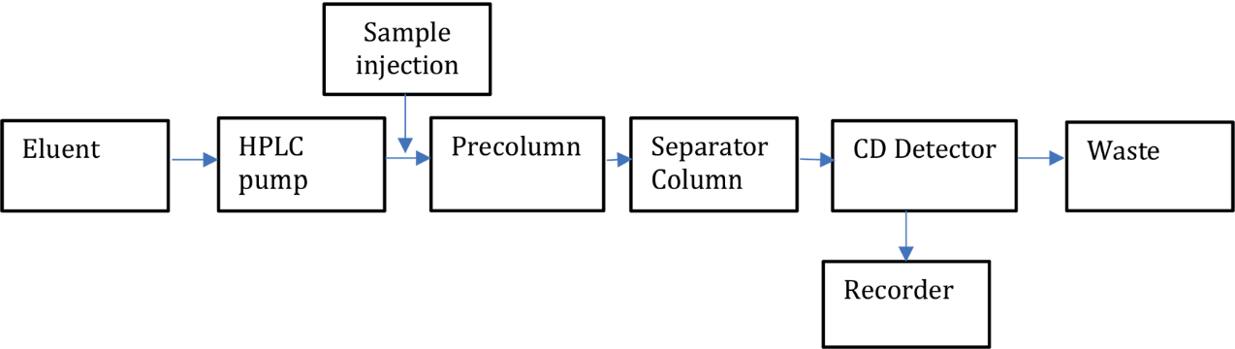

Figure 1 — Ion chromatographic system

## Quality requirements for the separator column

In chromatograms of samples and standard solutions, the peak resolution, *R*, between the anion of interest and its nearest peak, shall not fall below 1,3.

Separation conditions shall be such that possible interfering anions will not interfere with the anion of interest. Possible interactions are organic acids, such as acetic and formic acid. Where relevant, the column and separation conditions shall be assessed to confirm that no such interferences occur.

A pre-column is used to protect the column. It should be used if recommended by the manufacturer of the column.

# Sampling and sample pre-treatment

## General

Gaseous chlorides and fluorides can be sampled simultaneously. Two different methods can be used for the sampling, one based on quartz filter and the other on cartridges/sorbent tubes. For evaluating performances of the methods, a dynamic generation as indicated in Annex B can be used.

## Sampling equipment

### Filter

A quartz microfiber filter, suited for particulate matter of 10 µm and 2.5 µm, is impregnated by deposit of 500 µL of a carbonate solution prepared at 50 g Na2CO3 per liter. After impregnation, dry the filter in a ventilated oven at the temperature of about 50 °C at least 1 h.

Two alkali-impregnated quartz fiber filters are required. Place a first filter at the bottom of the sampling cassette and a second filter on the top of the sampling cassette.

### Cartridges

Use activated silica gel (20/40) specially cleaned glass fiber filters. The cartridges are divided into two sections by a glass fiber filter. The first part collects the HCl and HF and the second part is a backup section that eventually collects the amount of acids that have not been collected in the first part.

The sampling cassette with the impregnated filters can be stored 3 months after preparation.

### Pump

Use a leak-free pump capable of sampling gas at a set flow rate, for quartz filter sampling a pump with flow between 1 L min-1 to 3 L min-1 and for cartridges sampling, a pump with flow between 0,1 L min-1 to 1 L min-1.

## Sampling

### Filter-based method

The sampling is performed with controlled volume flow rates set at 1 L/min during 30 min onto the alkali-impregnated quartz fiber filters.

The two filters are positioned in succession in the holder with the second filter used as a control to verify if HCl or HF would break through the first filter.

### Cartridge-based method

In the sorbent tube the sampling is performed with a controlled flow volume set at most 0,5 L/min for 20 min or less if the sample contain high concentration of HCl or HF. The tube is divided in two sections, the second section to check if not all HCl or HF have been adsorbed in the first one.

For both methods, the volume flow rate shall be measured using a calibrated flow meter. The calibration shall take any effects from biomethane into consideration. The volume flow rate, temperature, pressure and sampling time shall be recorded. The volume gas is calculated as

 (1)

The compressibility factors  and  shall be calculated in accordance with ISO 6976. If the composition of the biomethane is not known, it shall be measured in accordance with ISO 6974. For the purpose of this document, the measurement uncertainty associated with the compressibility factors may be ignored.

Sample pre-treatment

## Filter-based method

### Open the cassette taking care not to lose any particles deposited on the walls and not to pollute the impregnated filters.

Place each filter used for sampling, laboratory and field blanks separately on the bottom of beakers or bottles. Place 20 mL of water on each filter. If necessary, this volume of water can be adapted to obtain an extract more concentrated.

Ultrasonic the vessels for 5 minutes in a bath at room temperature.

The extract shall be filtered at 0.45 µm with a nylon syringe filter before injection for the analysis.

### Cartridges-based method

Remove the tubes from the sampling line taking care not to break the glass.

Cut the first end of the trap, remove the glass wool and put it in the first vial. Remove the sorbent material from the tube and add it in the first polyethylene vial with 10 ml of solution of 0.003 M CO3-- / 0.0024 mol L-1 HCO3-. Boil the vial for 10 min in pure water, cool down and dilute with water in a graduate flask. Treat the back section in the same way.

If the volume is less than 10 ml, add water to 10 ml final volume of the extract.

# Procedure

## General

This analytical method described in ISO 10304-1 shall be used. Therefore, the following is only a reminder of the essentials of the procedure.

Set up the ion chromatographic system (7.1) according to the instrument manufacturer’s instructions. An example of a suitable analytical condition is provided in Annex A.

Run the eluent, wait for a stable baseline and ensure that the system is free of chloride and fluoride by injecting water.

Perform the calibration as described in 9.2. Measure the samples, calibration (6.6) and blank solution (6.7) as described in 9.3.

## Calibration

Prepare the calibration solutions as described in 6.6.

Inject the calibration solutions (see 6.6) including a blank to cover the expected concentration range of the samples, while remaining within the linear response range of the apparatus. Identify the peaks for anions by comparing the retention times with those of the calibration solutions (6.6). Deviation of retention times shall not exceed ± 10 % within a batch.

Using linear or quadratic regression, establish the equation of the reference straight line or curve.

Adjust the established calibration function, if necessary (e.g. measure standard solutions of different anion concentrations in the lower and upper third of the working range).

## Measurement

After establishing the calibration function, inject the sample into the chromatograph and measure the peaks as described above (9.2).

NOTE The use of a precolumn is recommended not only for the analyses of aqueous extract loaded with the matrices made of filter with carbonates but also to protect the analytical separator column.

If the concentration of the analyte exceeds the calibration range, dilute the sample or establish a separate calibration function for a higher working range and re-analyse it.

If the concentration of the analyte falls short of the calibration range, establish a separate calibration function for the lower working range, and re-analyse it, if necessary.

If matrix interferences are expected, use the method of standard addition to confirm the results (verify the peaks by comparing the retention time of the spiked sample with those of the original sample).

Measure the blank solution (6.7) in the same way as the sample.

# Calculation

Calculate the concentration, C(x-), in micrograms per liter, or milligrams per liter, of the ion chlorides and of the ions fluorides in the extract solution using the peak areas or peak heights according to the calibration function used (9.2).

Take into account all dilution steps.

The gaseous chlorides (HCl) and fluorides (HF) mass in the filters are calculated using the following formula:

 (2)

where

|  |  |  |
| --- | --- | --- |
|  | *m*(X) | is the quantity of gaseous chlorides or fluorides collected in µg; |
|  | *ρ*(X-) | is the concentration in ions chlorides or fluorides in µg/L; |
|  | *V*s | is the volume of extract solution (see 8.4), in liters (L); |
|  | *M*(X-) | is the molar mass of ions chlorides or fluorides; |
|  | *M*(X) | is the molar mass of hydrogen chloride or hydrogen fluoride. |

In function of the sampling conditions, the hydrogen chloride or hydrogen fluoride concentrations in biomethane are calculated using the following formula:

 (3)

where

|  |  |  |
| --- | --- | --- |
|  | *m*(X) | is the quantity of gaseous chlorides or fluorides collected in µg; |
|  | *ρ*(x) | is the concentration of gaseous hydrogen chlorides or hydrogen fluorides in biomethane in µg/m3; |
|  | *V*gas | is the sampling volume (see 8.3), in liters (L). |

In the evaluation of measurement uncertainty, the following factors should be taken into account:

— Repeatability;

— Reproducibility;

— Recovery;

— Sampling.

NOTE Guidance on the evaluation of measurement uncertainty and the evaluation of the performance of methods can be found in references.[4][5][6]

# Expression of results

The results shall be reported using SI Unit (e.g. µg/m3) and include the measurement uncertainty.

In general, values shall not be expressed to a degree of accuracy greater than three significant figures. The rounding of values will depend on the statistics of the quality control procedures mentioned earlier, and the requirements of the analysis.

The measurement uncertainty reported for the results should reflect the results from quality control measurements and incorporate the deviation between the individual readings for the sample in question.

# Performance characteristics

## Calibration check

For demonstration of calibration traceability, a calibration verification solution with certified concentration and known measurement uncertainty shall be used. Additionally, this solution or a calibration solution may be used for drift control during the measurement cycle. The accepted deviation shall be in the limit of the laboratory quality control policy.

## Performance data

The performance characteristics have been determined in a validation study. The results of this study are given in Annex A.

# Test report

The work carried out by the testing laboratory shall be covered by a report which accurately, clearly and unambiguously presents the test results and all other relevant information.

The test report shall contain

1) the date, time and location of sampling;

2) the value, expanded uncertainty, and coverage factor used;

3) the reference conditions used;

4) a reference to this document.

NOTE ISO/IEC 17025[7] contains further guidance on test reports.

1. (informative)  
     
   Characteristics of the method
   1. Analytical conditions

As an example, the analysis of the samples was performed on a Thermo Scientific chromatograph with conductimetric detector (model ICS 5000+).

The analytical conditions were:

— Precolumn and Column: AG19 and AS19 4 mm/250 mm (Thermo Scientific);

— Flow: 1 mL/min;

— Eluant: KOH;

— Temperature of the column: 30 °C;

— Injection volume: 25 µL;

— Elution mode : gradient of eluent concentration;

|  |  |  |
| --- | --- | --- |
| **Time (min)** | **Events** | **c/mmol L-1 KOH** |
| -7 | Stabilization | 10 |
| 0 | Start acquisition | 10 |
| 10 |  | 10 |
| 1001 |  | 45 |
| 17 |  | 45 |
| 1701 | End | 10 |

— Detection: conductimetric;

— Temperature of the conductimetric cell: 35 °C;

— Electrochemical suppression;

— Suppressor ASRS - 4mm (Thermo Scientific);

— Suppression current: 112 mA;

— Retention time: 5 min for F- and 8,02 min for Cl-.

* 1. Validation data

The method has been validated according to the NF T 90-210 standard.

The calibration ranges have been defined from:

— for HCl: 2 µg Cl-/filter to 1000 µg Cl-/filter equivalent to 0,07 mg/m3 to 34,3 mg/m3;

— for HF: 2 µg F-/filter to 500 µg F-/filter equivalent to 0,07 mg/m3 to 17,5 mg/m3.

The expanded uncertainties have been calculated according to the requirements of ISO 11352[8].

Table A.1 — Expanded uncertainties (*k* = 2) obtained at the various tested levels for the filter-based method

|  |  |  |  |  |
| --- | --- | --- | --- | --- |
| **Compound** | **0,49 mg/m3** | **0,98 mg/m3** | **6,13 mg/m3** | **23,3 mg/m3** |
| HCl | 37 % | 14 % | 37 % | 10 % |
|  |  |  |  |  |
| **Compound** | **0,71 mg/m3** | **3,83 mg/m3** | **15,3 mg/m3** |  |
| HF | 35 % | 40 % | 13 % |  |

Table A.2 — **Expanded uncertainties (*k* = 2) obtained at various tested levels for the cartridges-based method with sorbent tubes using dynamic gas generator as reference**

|  |  |  |  |
| --- | --- | --- | --- |
| **compound** | **5,09 mg/m3** | **10 mg/m3** | **15,17 mg/m3** |
| HCl | 12 % | 17 % | 31 % |

|  |  |  |
| --- | --- | --- |
| **compound** | **10,34 mg/m3** | **11,05 mg/m3** |
| HF | 50 % | 50 % |

As an example, an obtained chromatogram as showed in Figure A.1 with the chromatographic separation for chlorides and fluorides in a standard solution prepared at 0,5 mg /L (fluoride) and 1mg /L (chloride).

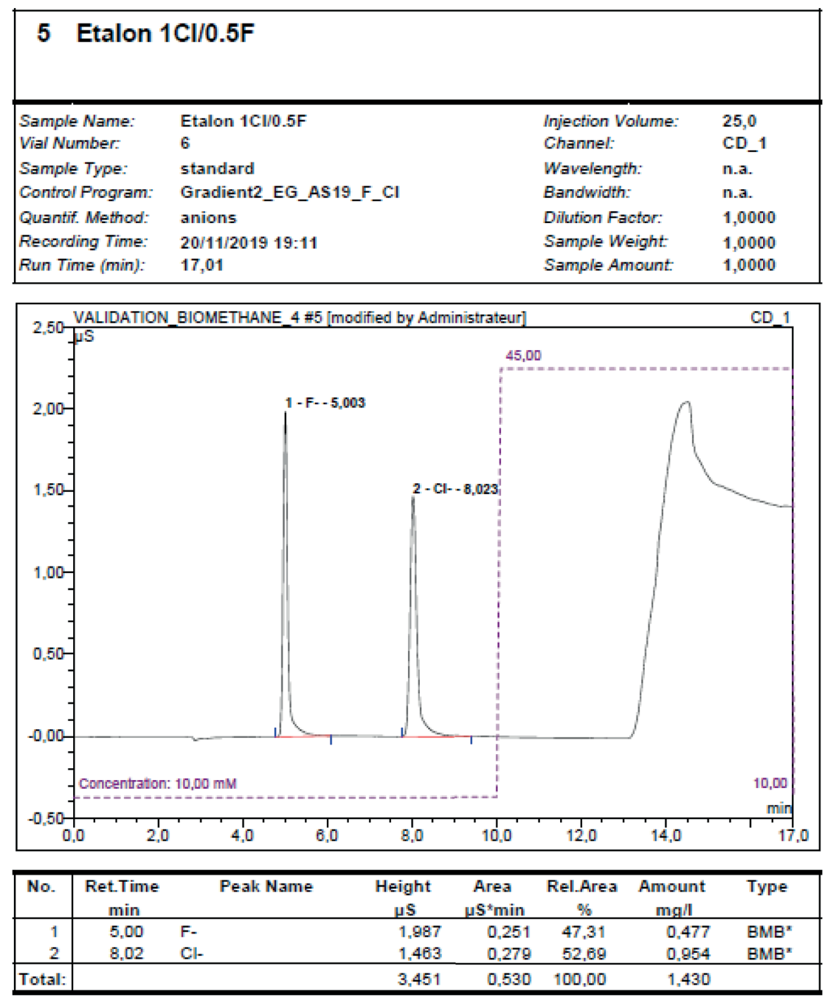

Figure A.1 — Example of IC chromatogram for a standard at 0.5 mg F-/L and 1mg Cl-/L

1. (informative)  
     
   Dynamic generation of HCl and HF

In gaseous form, HCl and HF are reactive chemicals that easily stick to sampling system surfaces. To estimate uncertainty caused by this effect on the analysis, dynamic generation method for HCl and/or HF containing reference gas is useable.

It is possible to apply the liquid evaporative method to dynamically generate reference gas mixtures with an accurately known concentration of HCl and/or HF, at relevant concentration levels. In this method, liquid solution with a known concentration of HCl and/or HF is mixed into carrier gas, e.g., methane or biomethane, using an evaporative generator.

Volumetric flow of liquid and gas streams in the generator are determined. Knowing the concentration of HCl and/or HF in the liquid solution, they are used to calculate concentration of the HCl and/or HF in generated reference gas flow.

Sampling and analysis of the reference gas flow is made as described in Clauses 8 and 9 of this document. From the results, the difference in calculated and analysed results is determined. This value gives an estimate of uncertainty of the method.

Bibliography

[1] EN 16723‑1:2016, Natural gas and biomethane for use in transport and biomethane for injection in the natural gas network – Part 1: Specifications for biomethane for injection in the natural gas network

[2] EN 16723‑2:2017, Natural gas and biomethane for use in transport and biomethane for injection in the natural gas network – Part 2: Automotive fuels specification

[3] ISO 13443:1996, Natural gas — Standard reference conditions

[4] Ellison S.L.R., Williams A., eds. Eurachem/CITAC guide: Quantifying Uncertainty in Analytical Measurement, Third edition, (2012) ISBN 978-0-948926-30-3. Available from [www.eurachem.org](http://www.eurachem.org).

[5] Ramsey M.H., Ellison S.L.R., Rostron P., eds. Eurachem/EUROLAB/ CITAC/Nordtest/AMC Guide: Measurement uncertainty arising from sampling: a guide to methods and approaches. Second Edition, Eurachem (2019). ISBN (978-0-948926-35-8). Available from <http://www.eurachem.org>

[6] Magnusson B., Örnemark U., eds. Eurachem Guide: The Fitness for Purpose of Analytical Methods – A Laboratory Guide to Method Validation and Related Topics, (2nd ed. 2014). ISBN 978-91-87461-59-0. Available from http://www.eurachem.org

[7] ISO/IEC 17025, General requirements for the competence of testing and calibration laboratories

[8] ISO 11352, Water quality — Estimation of measurement uncertainty based on validation and quality control data

[9] ISO 16140‑1, Microbiology of the food chain — Method validation — Part 1: Vocabulary

[10] NF T90-210, Qualité de l’eau – Protocole d’évaluation initiale des performances d’une méthode dans un laboratoire

[11] EN 16687, Construction products – Assessment of release of dangerous substances – Terminology

[12] ISO 11074, Soil quality – Vocabulary